**Non-verbal reasoning advanced objective questions and answers and tests for online practice**

Here are the most frequently asked non-verbal reasoning questions for your practice for UPSC exams, state PSC exams, entrance exams, bank exams, or any other competitive exams and job placement interviews. These tests are also useful for preparing for the Assessment of Competence-Technology (NAC-Tech) tests, conducted by NASSCOM, if you want to join major IT companies such as TCS, Cognizant, Wipro, Accenture and HCL among others. The non-verbal reasoning, also known as diagramatic reasoning or abstract reasoning, involves critical thinking, and tests one's ability to isolate and identify the various components of any given situation. A person with a higher non-verbal reasoning ability is better equipped to work in positions that require quick decision making. So, it is not a surprise that the non-verbal reasoning questions commonly appear in any placement tests, competitive exams or entrance exams.

1) There is some relationship between diagrams A & B. The same relationship persists between C & D. Find the right diagrams for D from the alternatives.  
  
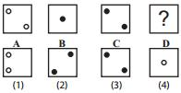 http://books.tamilcube.com/image/blank.gif

 **A.**1

 **B.**2

 **C.**3

 **D.**4

2) 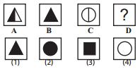 http://books.tamilcube.com/image/blank.gif

 **A.**1

 **B.**2

 **C.**3

 **D.**4

3) 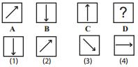 http://books.tamilcube.com/image/blank.gif

 **A.**1

 **B.**2

 **C.**3

 **D.**4

4) 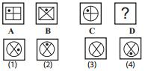 http://books.tamilcube.com/image/blank.gif

 **A.**1

 **B.**2

 **C.**3

 **D.**4

5) 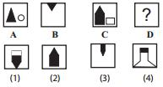 http://books.tamilcube.com/image/blank.gif

 **A.**1

 **B.**2

 **C.**3

 **D.**4

6) 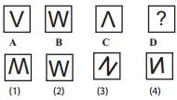 http://books.tamilcube.com/image/blank.gif

 **A.**1

 **B.**2

 **C.**3

 **D.**4

7) 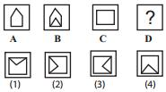 http://books.tamilcube.com/image/blank.gif

 **A.**1

 **B.**2

 **C.**3

 **D.**4

8) 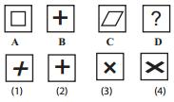 http://books.tamilcube.com/image/blank.gif

 **A.**1

 **B.**2

 **C.**3

 **D.**4

9) 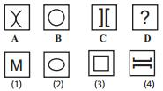 http://books.tamilcube.com/image/blank.gif

 **A.**1

 **B.**2

 **C.**3

 **D.**4

10) 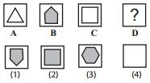 http://books.tamilcube.com/image/blank.gif

 **A.**1

 **B.**2

 **C.**3

 **D.**4

1) Directions for Q.No.1 to 10: Choose the figure which is different :  
  
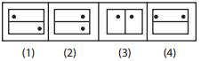 http://books.tamilcube.com/image/blank.gif

 **A.**1

 **B.**2

 **C.**3

 **D.**4

2) 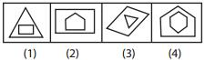 http://books.tamilcube.com/image/blank.gif

 **A.**1

 **B.**2

 **C.**3

 **D.**4

3) 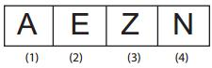 http://books.tamilcube.com/image/blank.gif

 **A.**1

 **B.**2

 **C.**3

 **D.**4

4) 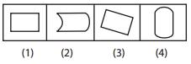 http://books.tamilcube.com/image/blank.gif

 **A.**1

 **B.**2

 **C.**3

 **D.**4

5) 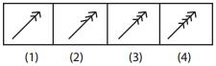 http://books.tamilcube.com/image/blank.gif

 **A.**1

 **B.**2

 **C.**3

 **D.**4

6) 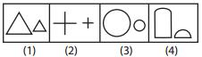 http://books.tamilcube.com/image/blank.gif

 **A.**1

 **B.**2

 **C.**3

 **D.**4

7) 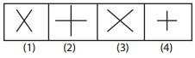 http://books.tamilcube.com/image/blank.gif

 **A.**1

 **B.**2

 **C.**3

 **D.**4

8) 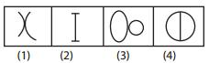 http://books.tamilcube.com/image/blank.gif

 **A.**1

 **B.**2

 **C.**3

 **D.**4

9) 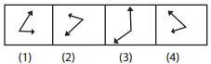 http://books.tamilcube.com/image/blank.gif

 **A.**1

 **B.**2

 **C.**3

 **D.**4

10) 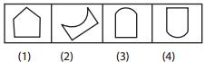 http://books.tamilcube.com/image/blank.gif

 **A.**1

 **B.**2

 **C.**3

 **D.**4

[View Answer / Explanation](javascript:void(0);)